ECA6102 – COMPUTER NETWORKS AND CYBERSECURITY

NAME: Pavitra I
REG.NO: 192512035
EXP – 02
Design and Implementation of VLAN Segmentation and Inter-VLAN Routing for a Multi-Department Network using Cisco Packet Tracer
- VLAN Configuration
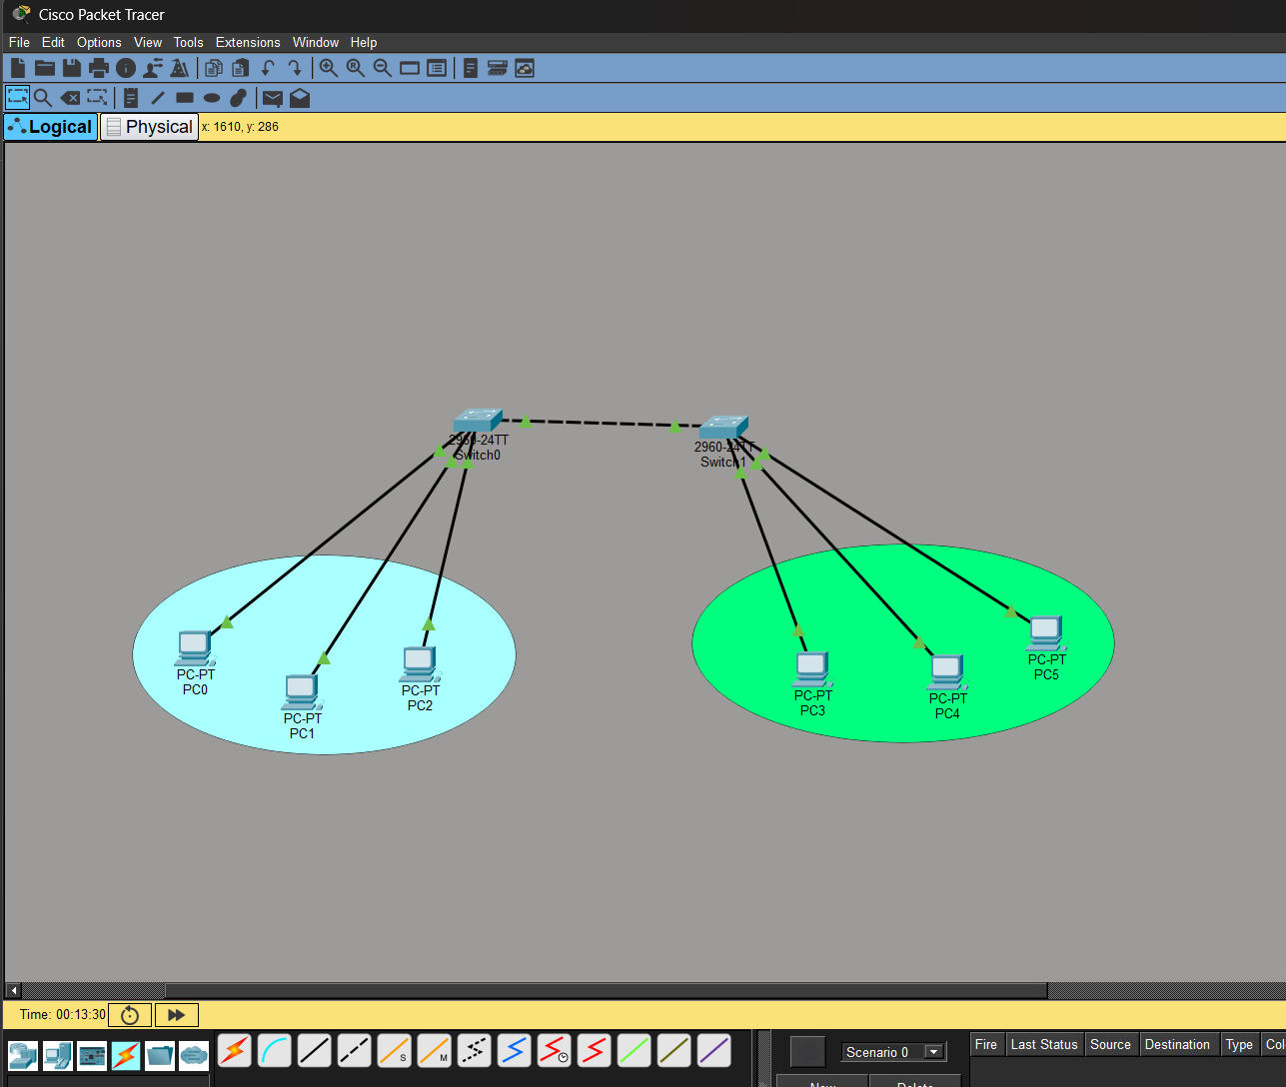

OUTPUT:

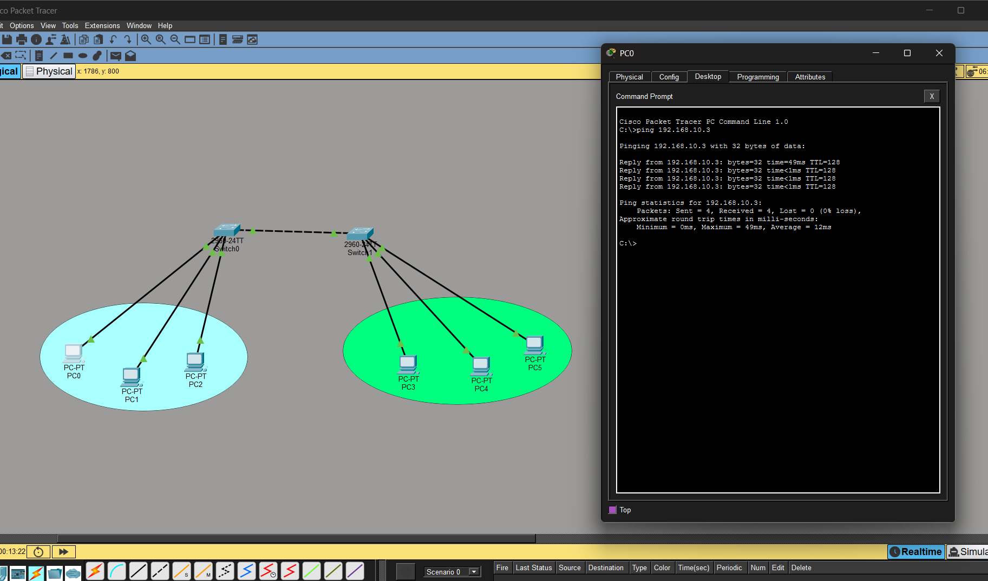
- Inter-VLAN Configuration
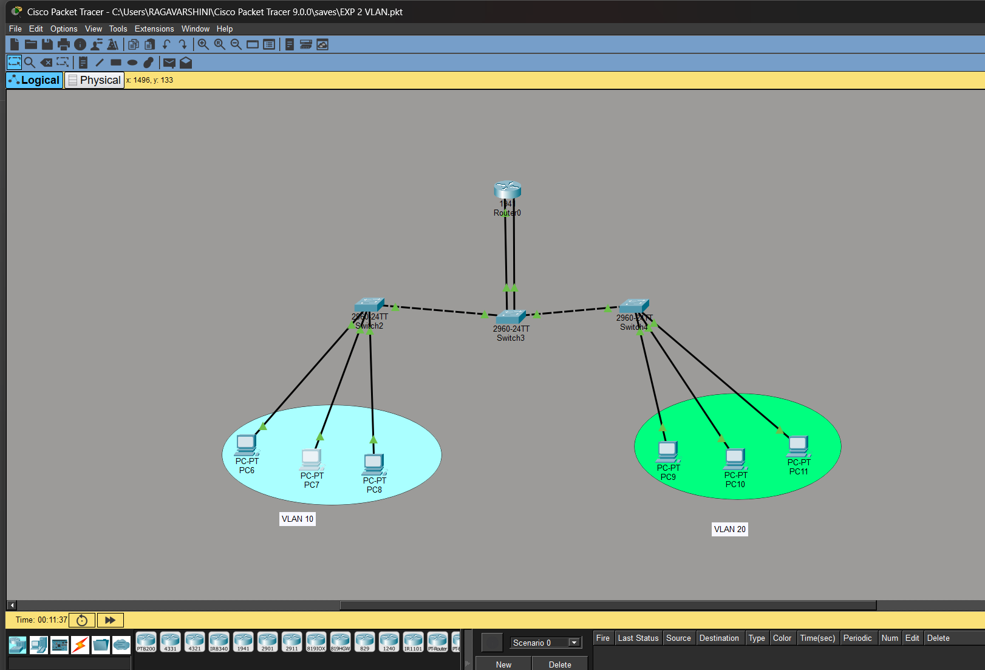
OUTPUT:

